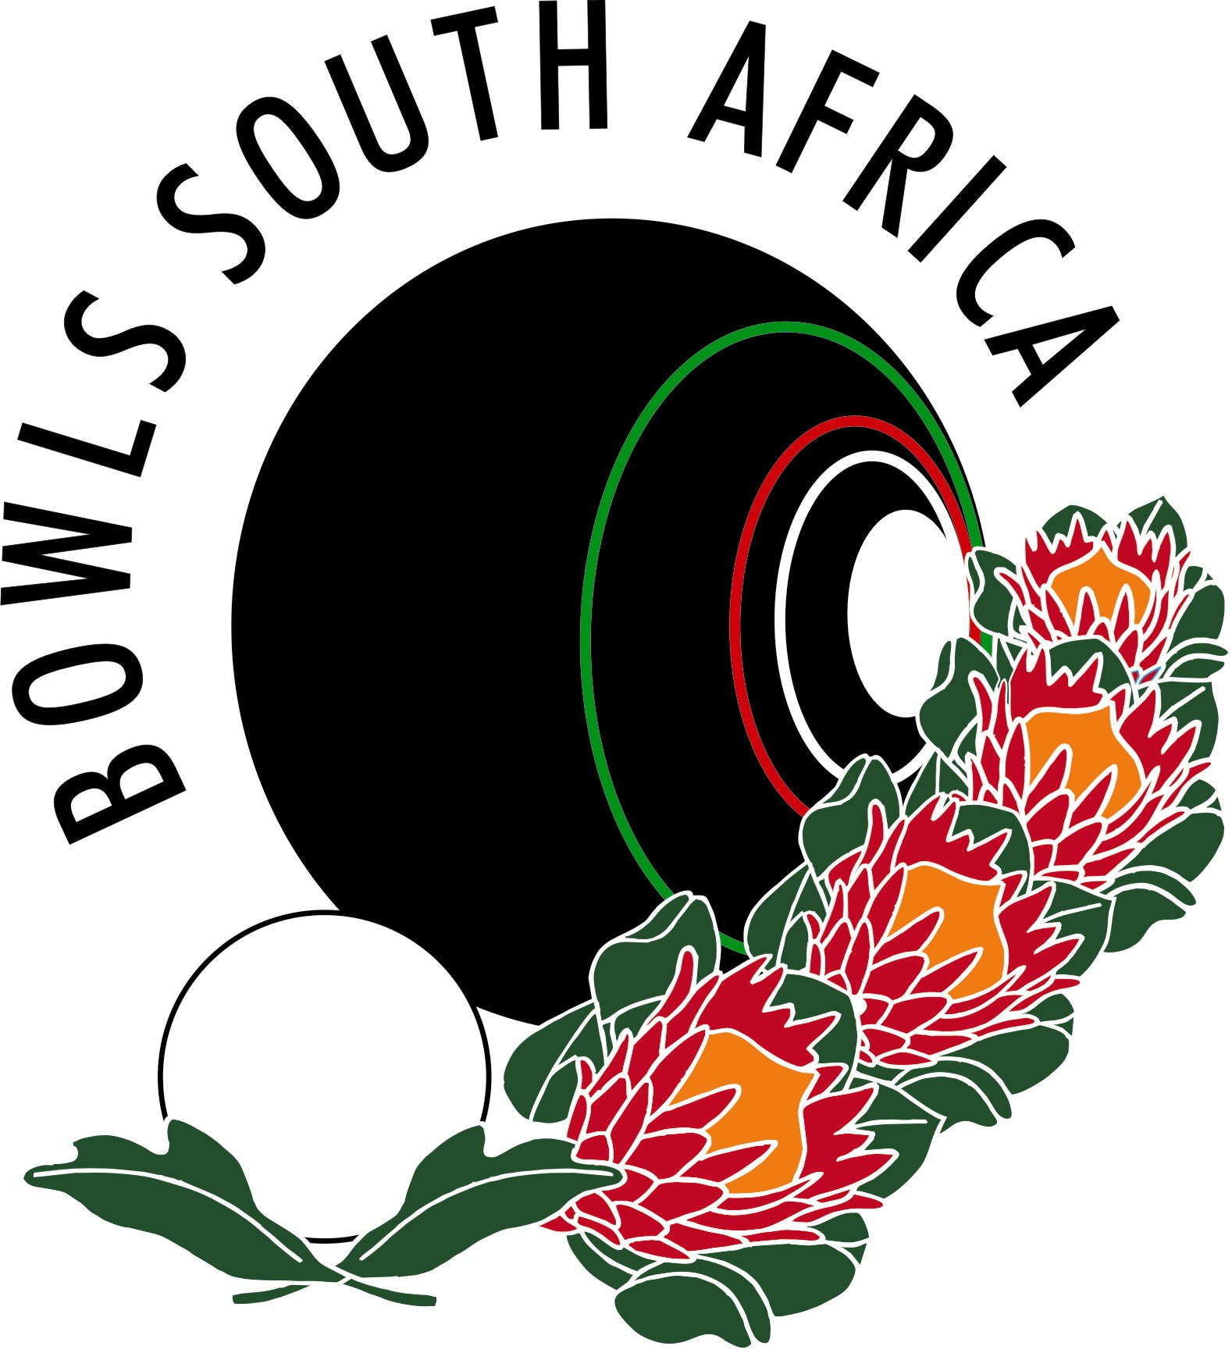BOWLS SOUTH AFRICA TECHNICAL OFFICIALS

To the point
Issue 2/2024 JUNE 2024
Author J Williams

1. ETIQUETTE IN BOWLS

Good manners will open doors that the best education cannot. Good manners are expected when we interface with opponents on the bowling green. The problem is that good manners differ from one social group to the next and this is where etiquette comes in. Etiquette is a set of rules governing socially acceptable behaviour. As in all other sports, bowls has a written and a stated etiquette.

These basic rules are essential and are used by both serious and recreational bowlers. These rules provide a basic understanding amongst all bowlers and ensure that everyone has fun at an afternoon of bowls. We can usually identify those bowlers who are too serious. A few very serious bowlers use the rules of etiquette to restrict, discourage and exclude others. They resent anyone who threatens them in any way. The primary objective of etiquette is to ensure that every one is treated courteously and with respect. Good bowling requires concentration. Have fun but keep in mind that excessive movement or noise could be distracting when others are ready to deliver their bowl. Refrain from using abusive language; this is not the image that we wish to present.

Play the game to win but be a gracious loser. Good sportsmanship is always the key to a successful game. Be a good sport. No one wants to share time with a sore loser or someone who is angry, irritable or speaks badly of others.

The problem of poor etiquette and bad manners on a bowling green should: be sorted out at club level and clubs should also see to the adherence of the laws when social bowls is played. Sadly this is something that has been allowed to fall by the wayside in many clubs even though we have addressed this matter previously

2.QUESTION
I would value “opinions” on what is the correct action in the scenario of which I have attached a photo.
In the picture attached there are 3 bowls. They are all very near the boundary line of the rink and the applicants are asked what they would do faced with this scenario.
The bowl on the left and the jack are in the rink - confirmed by a string/mirror/boundary scope. The bowl on the far right is clearly out the rink. The middle bowl is on the boundary line and is leaning against the dead bowl. If you move the dead bowl the middle bowl will fall out of the rink. What would you do as umpire?
The reason I’m asking is that there was a difference of opinion as to what was the correct action. I’ll give you the “decisions” when you have given your opinion!.


Fri, Sep 20, 2:15 PM (11 days ago)

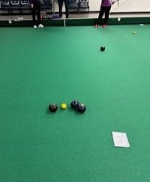

ANSWER
You remove the dead bowl, if the other bowl falls out it is also dead.

3.QUESTION
In our Level 1 session on Thursday we had a discussion concerning Domestic Regulations Law 53.5 which reads,
All bowls used by players in the SA Masters should have World Bowls Stamp not older than 10 years”.
Does this mean that the bowls can be used for 10 years after the expiry date on the stamp, i.e. if the date on the bowls is 17, can they be used up to December 2027?

ANSWER
No it means that the date that is stamped on the bowls is the year in which they expire.

4. DRESS CODE
World Bowls have approved the wearing of shirts with a Bishops Collar otherwise known as the Mandarin Colar



5.CAPS

A query was also received about the wearing of caps. Bowls South Africa sent out a Circular stating players are permitted to wear caps back to front.

TECHNICAL OFFICIALS STANDING COMMITTEE


Comments may be E-mailed to any of the Committee Members.

Jeanette Williams – Convener brujenw@gmail.com
Dirk Malomgre dmalomgre@mweb.co.za
Howard Gibbons howardgib.@gmail.com
Lynton Harrison lynton.harrison@gmail.com
Francois Schutte frs1@vodamail.co.za
Almarie du Toit almariedt@gmail.com
Copies of this newsletter will be circulated to all District Secretaries and are available on the Bowls SA web site.

